CST 2250 COURSEWORK 1 ADEYINKA OPEYEMI ADESANYA M00784267

INTRODUCTION

* M00784267
* My project is a Library Management System, which consists of functions for adding members, borrowing, and returning books, and to see if a fine needs to be allocated for late returns.
* The presentation will evaluate the implementation of my work, how I work the code and the function which was added.

DESIGN

* UML design

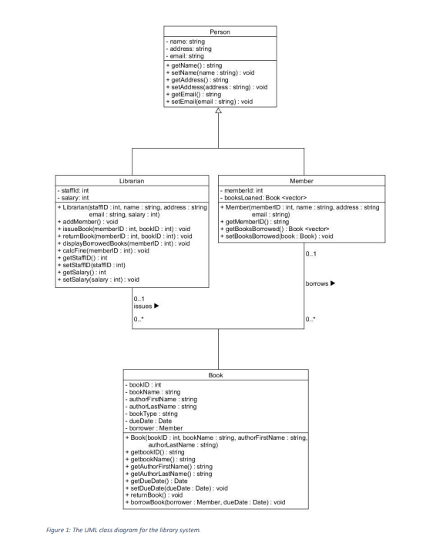

This was the UML provided by lectures

Use case design.

Class activity diagram

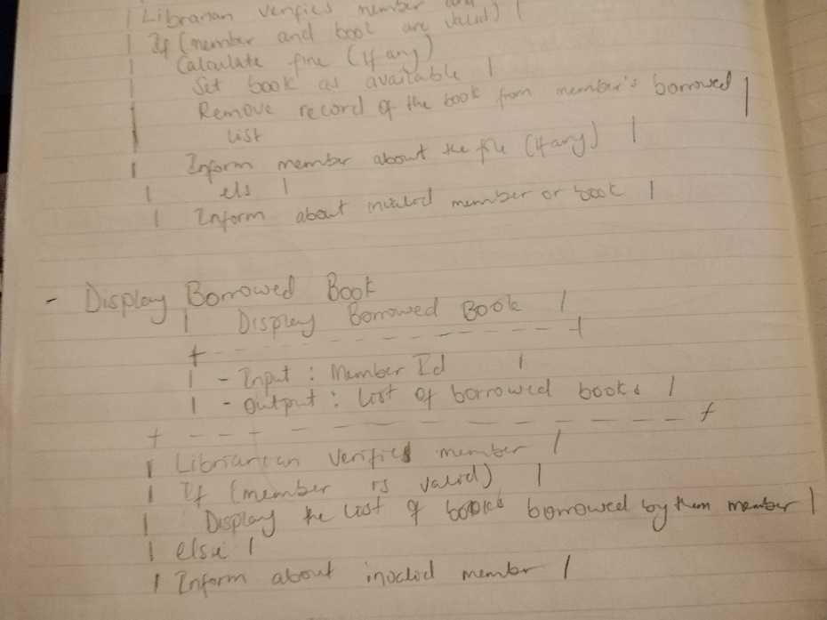

IMPLEMENTATION

Make file and version control.

* The Make file in the provided C++ project was used to automate the build process, defining rules for compiling, linking, and generating the final executable. It facilitated a standardized and efficient build process, supporting incremental builds and parallel compilation. The Make file included targets for cleaning up compiled files.
* Version control, specifically Git, was used in conjunction with the project for collaboration, history tracking, branching, merging, rollbacks, and collaborative problem-solving. It provided a systematic approach to managing and tracking changes in the codebase, ensuring consistency, facilitating teamwork, and enabling continuous integration practices. Both the Make file and version control were essential tools in the software development process.
* – Include a screenshot of the Bitbucket/GitHub repository which clearly shows all commits and commit messages.

TESTING APPROACH

* For the texting approach, I do not know what I've done and hopefully could be explained to me what I should have done right well. I just created a test case, but I do not really understand it perfectly, and my code doesn't compile or run so I just let it be but next time hopefully before the next course work I would understand what she should have done better

CONCLUSION

* This is a summary for coursework1, the code implementation of the library management system was created, and it has the function in the library of issuing a book as a new member, issuing book to the member, adding a book, return book, borrowing book and calculating fines for the due date which were all written in for the book and added a CSV file.
* The limitation in this work will be the act of being unable to use GitHub and commit regularly. I also had lots of issues in writing the program as why the program wasn’t running well with errors.
* I will have to improve my understanding and the catch too testing because I could not do the testing in a testcase properly so that is a cause of limitation to my work.
* I will approach a similar project differently,
* First, improve my understanding in C++. Ability to understand how to write a catch2 test cases by following a well-structured plan and breakdown of how to start the project. if I must do it again, I will watch video and have more understanding of and ask for help when required.